Protecting Our Homes from Urban Wildfire
As the residents of Colorado Springs and Herriman have found out,
suburban areas are not immune to wildfires.

A Preparedness Seminar

Presented by the Bountiful City Emergency Preparedness Council, the South Davis Metro Fire Agency and the

Utah Department of Natural Resources
Colorado Springs Fire 2012
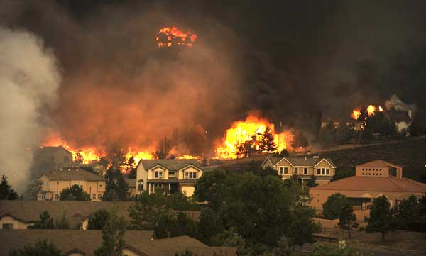

The following will be presented:

Chief Jeff Bassett
Chief Jeff Bassett of the South Davis Metro Fire Agency will discuss specific concerns that SDMF has with the Bountiful foothills and gullies, and the very real fire danger that could result in the loss of many of our homes.

Brianna Binnebose
Brianna Binnebose, Wasatch Front Wildland Urban Interface Coordinator, will discuss how we as residents and neighbors can reduce our exposure to wildfires and prepare homes that border wildlands with defensive areas while maintaining a natural landscape that preserves a woodland look.

Exhibits
Exhibits will be presented that demonstrate how fast wildfires can sweep through an area and the damage that we in Bountiful can expect.

With summer conditions forecast to be extremely dry and concerns by fire officials mounting for this summers’ fire season, it is important for us to do as much as possible to prepare for the possibility of fire around our homes. This is one potential disaster that we as a city can actually prepare for in advance, and take actions that can protect us from harm.

Tuesday, May 19th, 2015
7-8 pm
South Davis Junior High School Cafeteria

Wildfire preparation increases the potential that homes will survive wildfire. By preparing homes and property ahead of time, we can better protect our homes, investment, surrounding area and families. If each of us does our part, we can collectively create a safer environment.
-Utah Firewise Living-
A Wildfire Preparation Guide, published through the Utah Division of Forestry.

Come and learn what you can do to assure your property is as prepared as it can be.

